**Invitation**

Distinguished Media,

The 2nd annual World Peace Forum (also known as the “Tsinghua Forum”) will be held on June 27 and 28 of this year at Tsinghua University. Organized by Tsinghua University in coordination with the Chinese People’s Institute of Foreign Affairs, the Forum was started in 2012 and is the first high-level non-governmental international security forum in China. The first World Peace Forum received extensive media coverage and commentary from all over the world.

The topic of this year’s forum is tentatively set as “International Security in a Changing World: Peace, Development, Innovation.” The forum will be separated into three different types of events: Major conferences, roundtable discussions, and small group panels. The major conferences and small group panels will be open to media, and there will also be seven press conferences. We also invite all journalists to speak with current and former government officials and other forum participants during breaks.

Your participation in this event would mean great support for our institution, and we look forward to your contributions.

(Attached is background information regarding the Forum, a media agenda, a press conference schedule, and a map. If you or your colleagues plan to attend the forum, please fill out the attachment titled “Registration Form” with a photograph and return it to [wpfmedia@hotmail.com](mailto:wpfmedia@hotmail.com). Thank you for your cooperation!)

June 2013

Institute of Modern International Relations

Tsinghua University

**Background**

Tsinghua University held the first World Peace Forum on July 7-8, 2012. The Forum was the first high-level non-governmental forum on international security in China and focused on creating a platform for international strategy and think-tank leaders to discuss international security issues and search for constructive solutions. Former State Councilor Tang Jiaxuan chaired the event co-organized by the Chinese People’s Institute of Foreign Affairs.

Then-Vice President of the People’s Republic of China Xi Jinping and seven other former national leaders attended the 2012 forum. These seven national leaders were: Alan Garcia (former President of Peru), Abdullah Ahmad Badawi (former Prime Minister of Malaysia), Shaukat Aziz (former Prime Minister of Pakistan), Dominique de Villepin (former Prime Minister of France), Yukio Hatoyama (former Prime Minister of Japan), Igor Ivanov (former Secretary of the Russian Security Council), and Javier Solana (former EU High Representative for Common Foreign and Security Policy).

The first World Peace Forum consisted of three major conferences, two roundtable discussions, an evening banquet, and eighteen small group panels. The small group panels were led by various nations’ ambassadors to China. In total, 22 think tank leaders, 36 ambassadors to China, and 150 think-tank experts and entrepreneurs attended the forum. Other than domestic media, 42 media outlets from 21 different countries reported on the event.

**Upcoming 2013 World Peace Forum**

The 2nd annual World Peace Forum will be held at Tsinghua University on June 27-28, 2013. The forum’s theme is "International Security in a Changing World: Peace, Development, Innovation."

Hosted by Tsinghua University and co-organized by the Chinese People’s Institute of Foreign Affairs, the World Peace Forum was founded in 2012 and is the first high-level non-governmental international security forum in China. The Forum is held every summer at Tsinghua University with the purpose of providing a platform for international strategy experts to discuss issues such as global or regional security threats, ways to increase international security cooperation, and how to achieve lasting peace.

In 2012 the first World Peace Forum invited seven former national leaders: former Peruvian President Alan Garcia, former Malaysian Prime Minister Abdullah Ahmad Badawi, former Pakistani Prime Minister Shaukat Aziz, former French Prime Minister Dominique de Villepin, former Japanese Prime Minister Yukio Hatoyama, former Russian National Security Council Secretary Ivanov and former EU High Representative for Common Foreign and Security Policy Javier Solana. Including experts from 22 countries and 36 different countries’ ambassadors to China, nearly 450 people attended the opening ceremony.

Then-Vice President Xi Jinping attended the ceremony and said in his opening address (as cited by Xinhua News Agency), "A country which pursues its own development, security and well-being must also let other countries pursue their development, security and well-being. All countries must take a cooperative approach with an innovative spirit and responsible attitude, stand together and seek win-win cooperation to resolve various problems and challenges, and foster a harmonious and stable international and regional security environment.” This view is considered by foreign media to have set the tone for China’s diplomacy in the next decade.

At the 2012 forum, foreign media focused on China’s peaceful rise, its concepts and promises for a peaceful world, and its policy towards neighboring countries. In 2013, many complex and challenging global and regional security issues remain, and the international community is becoming increasingly concerned about the attitudes and behaviors of China in international security issues. To this end, the 2013 World Peace Forum will focus on international security trends, innovative approaches toward maintaining international security, areas of collaboration, and the development of international security relations through high-level dialogues. Compared to the 2012 Forum, the 2013 Forum will involve a greater number of higher-profile participants from more countries.

We look forward to the 2013 World Peace Forum and hope to improve on last year and achieve even greater results.

|  |  |  |
| --- | --- | --- |
| Name |  | Photo |
| Company and Title |  |
| Contact Number |  |
| E-mail |  |
| Passport or ID Number |  | |
| Press Conference | □6/21 Fri | |
| Attend World Peace Forum | □6/27 Thu □6/28 Fri | |

**Registration Form**

【In order to ensure proper forum security and registration, please complete the “Registration Form” ASAP and return to [wpfmedia@hotmail.com](mailto:wpfmedia@hotmail.com) before 17:00, June 17. For security purposes PASSPORT NUMBER or CHINESE ID NUMBER is required. Due to the high-profile nature of the event, we cannot allow any media personnel to register without a photograph. Thank you for your cooperation. 】

**Press Conference:**

Time: 9:30 AM, June 21, 2013

Location: Room 327, Main Building of Tsinghua University

**Contact Us**

World Peace Forum Secretariat Office

Nicole Wu: 18810717268

Rudy W. Wu: 18801392284

Office: 010-57163448

Fax: 010-62786023

Email: [wpfmedia@hotmail.com](mailto:请将参会回执通过电子邮件方式发送至worldpeaceforum@tsinghua.edu.cn)

Official Website: www.imir.tsinghua.edu.cn

www.wpfforum.org

**2013 World Peace Forum Media Agenda (Draft)**

**International Security in a Changing World:**

**Peace, Development, Innovation**

**Organizer: Tsinghua University**

**Co-organizer: Chinese People's Institute of Foreign Affairs**

**Venue: Main Building of Tsinghua University**

**Date: 27-28 June, 2013**

**27thJune (Thursday)**

09:40-11:40 **OPENING CEREMONY &** **CONFERENCE**

**(**Main Building, Tsinghua University)

Host: **Chen Jining**

President, Tsinghua University

Chair: **Tang Jiaxuan**

Chairman, World Peace Forum

Theme: Trends in International Security

11:40-12:30 to Liaoning International Hotel

12:30-14:30 **LUNCH MEETING**

13:50-14:20 **PRESS CONFERENCE (1):CHINA’S GOOD-NEIGHBORLY AND FRIENDLY RELATIONS**

14:30-16:00 **CONFERENCE**

Theme: Innovation and International Security

Chair: **Fu Ying**

Director, National People’s Congress Foreign Affairs Committee

16:00-16:30 **BREAK**

16:00-16:30 **PRESS CONFERENCE (2): CHINA-ASEAN SECURITY COOPERATION**

16:30-18:00 **PANELS**

1. Changing Structure of International Relations and Impact on International Security
2. Conceptual Innovation to Maintain International Security
3. The National Rejuvenation of China and Its Diplomacy Adjustment
4. Security Issues in the Middle East and Their Implications
5. International Cooperation on Cyber Security
6. Religion and International Security

18:00-18:30 **PRESS CONFERENCE (3): REGIONAL NUCLEAR NONPROLIFERATION**

18:30-20:00 **EVENING BANQUET**

**28thJune (Friday)**

8:30-10:00 **PANELS**

1. Major Threats to International Security
2. Non-Traditional Security Issues
3. Relations Between China and Its Neighbors
4. Regional Security in East Asia
5. South-South Cooperation and International Security
6. Building a New Type of Great Power Relations
7. Our Peaceful Future: Shared Responsibilities and Innovation by Civil Society, Business and Government

10:00-10:30 **BREAK**

10:00-10:30 **PRESS CONFERENCE (4): MARITIME SECURITY**

10:30-12:30 **CONFERENCE**

Theme: International Coordination and International Security

Chair: **Lu Shumin**

Vice President, Chinese People's Institute of Foreign Affairs

12:30-14:00 **LUNCH MEETING**

13:20-13:50 **PRESS CONFERENCE(5): DEVELOPMENT AND SECURITY IN SOUTH ASIA**

14:00-15:00 **CONFERENCE**

Theme: Social Development and International Security

Chair: **Chen Jian**

14:10-14:40 **PRESS CONFERENCE(6): MECHANISMS FOR ASIA-PACIFIC SECURITY COOPERATION**

15:00-15:30 **BREAK**

15:00-15:30 **PRESS CONFERENCE(7): US-CHINA SECURITY COOPERATION**

15:30-17:00 **PANELS**

1. Regional Security in Africa
2. Non-Proliferation of Nuclear Weapons and Nuclear Security
3. International Intervention and International Security
4. China-US Security Relations and Asia-Pacific Security
5. Regional Security Cooperation

17:10 **PRESS CONFERENCE BY WORLD PEACE FORUM SECRETARIAT**

**OFFICE**

18:00 **DINNER**

**World Peace Forum Press Conference**

**Agenda:** World Peace Forum Press Conference

**Date and Time**: 9:30, 21st June, 2013

**Place**: Room 327, Main Building of Tsinghua University

**Participants:**

Moderator: Sun Xuefeng

Chief Organizer: Yan Xuetong

**Schedule:**

|  |  |
| --- | --- |
| 9:30-9:55 am | Press Registration and Distribution of Conference Materials |
| 9:55-10:00 am | Media Preparation for Press Conference |
| 10:00-10:05 am | Press Conference Begins |
| 10:05-10:20 am | Introduction of “World Peace Forum“ by Forum General Secretary Yan Xuetong |
| 10:20-11:00 am | Q&A |
| 11:00 am | End of the Press Conference |

Directions to Main Building of Tsinghua University

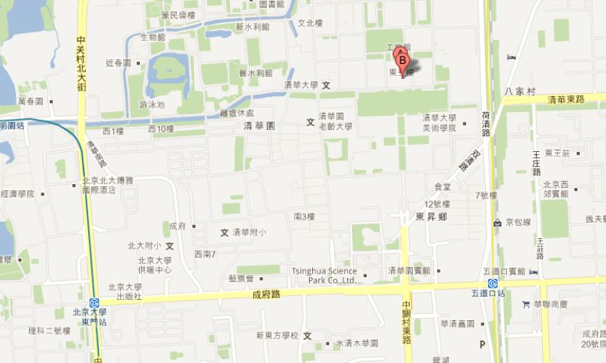

←Main Building

* Enter the Main Gate of Tsinghua University by proceeding north on Zhongguancun East Road (中关村东路). The Main Building is located due north of the Main Gate.
* See <http://www.tsinghua.edu.cn/publish/th/6258/index.html> for a map of the campus of Tsinghua University.